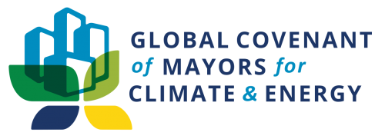

Regional/National Covenant Strategy and Strategic Plan 2022 – 2024

Recommended process and template
This document aims to provide a common structure and guidance for the development of Regional/National Strategies aligned with GCoM Strategic Plan 2022-2024.

The document will include:
- Global Strategic Plan 2022-2024 at a glance
- Recommended approach for the process to formulate the Regional Strategy and Strategic Plan – including an overview of the governance structure and context in the R/N Covenant, roles and responsibilities (Secretariat, Helpdesk, Steering Group/Coordination Group)
- Regional/National Strategy template:
  - Priorities goals and delivery pathways identified in alignment with GCoM Strategic Plan.
  - Alignment with/impact on national/regional priorities on the basis of the RLC definition and playbook,
  - Strategic workplan including activities planned, proposed (including a calendar).
  - Highlights from implementation of goals.

Global Strategic Plan 2021-2024 at a glance
GCoM`s overarching strategy is organized around a set of three goals that describe our aspirations or destination points.
They will serve as the overarching focus areas of all our activities, and represent the direction our community will follow to channel resources, empower the GCoM alliance, and drive its impact.

Goal 1 |  | Grow the GCoM alliance to include more cities and new audiences
Goal 2 |  | Deepen engagement with cities and local governments already committed to climate action
Goal 3 |  | Accelerate large-scale systems change for just, inclusive, and equitable city climate action

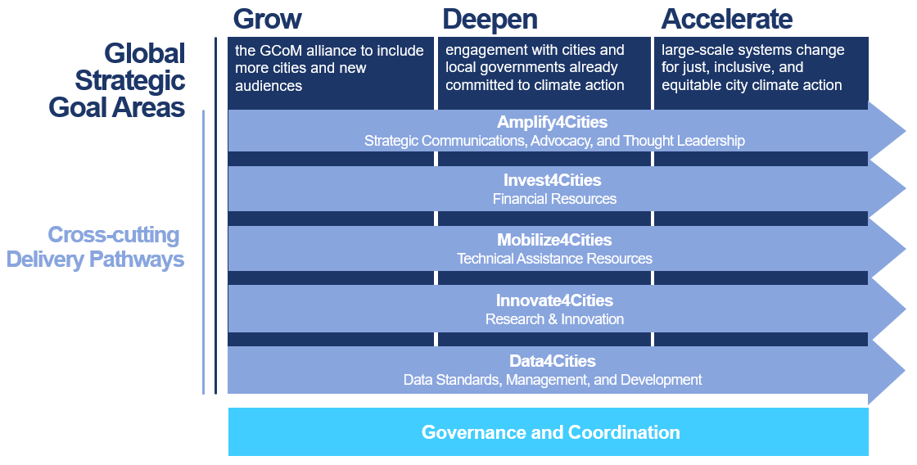

Recommendations and guidelines for Regional/National strategy development process

The aim of the R/N Strategies is to identify, set, and further common priorities and objectives within a GCoM Region. They are co-created by the Regional/National Covenant partners, and they are aligned with the GCoM Global Strategic plan. They include an overview of how each Regional/National Covenant aims to prioritize the implementation of its specific goals, whilst considering regional/national context and needs. The alignment with the Global Strategic Plan aims at contributing to the GCoM Regional-Global coherence and consequently to the global impact of the Alliance.

The core of the development process of these strategies is to ensure a coherent vision and goals are shared by the GCoM globally, while also considering R/N Covenants’ context and objectives.

The strategies provide a platform to further discussion and cooperation amongst key partners in the R/N Covenants: the development of the strategy must be a co-development and co-creation process, where each partner can highlight, present and inform the objectives, delivery pathways and activities identified, on equal footing.

To that end, it is important to consider three principles in the process:
- Inclusiveness: motivate participation of all R/N Covenant’ partners organizations in the prioritization of objectives and actions is essential for effective implementation and fostering cohesion in the group.
- Co-creation: actively engage all partners forming the steering group to participate in the development of the Regional Strategy in order to have a common framework for action in the region that enables consistency in the Alliance. The role of the Secretariat is to facilitate this process of co-development, according to share principles and goals.
- Cooperation and collaboration: foster a coordinated approach in order to identify and strengthen synergies and contribute to a more productive and efficient process. This allows identification and commitment of human and financial resources needed for implementation in a complementary mode.

The recommended steps include:

- Finalize the governance structure in the region (e.g. Steering group, Political Boards) and the coordination mechanisms (monthly meetings, etc). Please refer to the following documents available in the Regions Portal: GCoM governance Regional-Global.ptt and GCoM Regional Coordination Protocol.doc.
- Organize a preliminary meeting to agree on the approach to develop the Regional Strategy (number of meetings, group dynamic to fill in the matrix, etc.) based on the 3 principles mentioned above. The 3 principles should be shared and discussed with partners in order to have a common understanding of its significance and practice.
- Based on the approach defined, organize a number of meetings with partners to fill in the format below, in line with Regional/National Covenant structures. These meetings at least for the first phase are recommended to coincide with the monthly coordination meetings between GCoM and Regional /National Covenant.
Suggested steps for the Secretariat to facilitate the co-develop of the strategy with the Steering Group:
- Discuss GCoM Strategic Workplan and identify priorities/alignment with Regional/National context.
- For each GCoM Strategic Plan’s goals, reflect collectively about the focus and priorities in the region, and define the main results. Consider the existing challenges and opportunities.
- Identify partners’ on-going activities that contribute to those results, explore the synergies and foster cooperation and collaboration.
- Define activities, the actors responsible and the timeline. Note that the more detailed are the responsibilities the easier to follow up commitments.
- Agree on Progress tracking process (e.g. collective review during coordination meetings, etc.).

GCoM Secretariat will support: (i) preparation of the methodological approach to formulate the strategy; (ii) support the facilitation of the work with partners during the Monthly Coordination calls or ad-hoc meetings, (iii) clarify, share information on global Strategic Workplan and relevant regional strategies.

Regional/National Covenant Strategy template (with examples)

GCoM  Strategic Plan goals | Regional Prioritization and alignment with National Plans/NDCs, etc. | Delivery pathways & measures:  (including existing targets) | Outputs and Progress tracking (e.g. through contract reporting, projects etc.) | Role/Actors responsible | Timeline
GROW  the GCoM  alliance to include more  small and mid-sized cities, as well as those who have not yet  prioritized climate | Priority 1 - Create buy-in in national government in support of GCoM is essential to increase number of cities engaged in GCoM | Reach out to unions of local authorities where applicable | Output: 5 Unions of Local Authorities approached; 30 new signatories  Organise capacity building workshops and Joint events with other cities for experience sharing  Achieved progress: N/A | Lead:  Clima-Med/helpdesk  Contributor:  Clima-Med/helpdesk  JRC (?) | Signatories on board by mid 2023
 |  | Promote and support the establishment of an official, operational, and sustained SEACAP Support Mechanism (SSM) as a support system responsible for the plans’ preparation and implementation | Output: 6 SSMs established; 60 new signatories | Lead: Clima-Med experts  Contributor: | End of 2024
 | Priority 2 – Engage subnational governance levels and other stakeholders to activate their LAs | Depending on the governance structure, contact governorates / districts etc. to discuss the support they can provide to their capital cities, together with the city mayor | Output: At least 10 governorates contacted; 5 new signatories  Achieved progress: N/A | Lead:  Clima-Med Team | Contacts and meetings realized by end 2022
 |  | Following up on cities having received TA from Clima-Med, to become signatory. | Output: 70 cities contacted; 50 new signatories  Achieved progress: N/A | Lead:  Secretariat/helpdesk  Contributor: | By March 2023
 | Priority 3 – Mobilising local governments through direct contact | Following up on cities having received TA from ClimaMed, to become signatory. | Output: 70 cities contacted; 40 new signatories  Achieved progress: N/A | Lead:  Secretariat/helpdesk  Contributor: | By March 2023
 |  | Contacting dormant cities, or cities with commitments up to 2020, to renew their commitment. | Output: 70 cities contacted; 10 commitments renewed  Achieved progress: N/A | Lead:  Secretariat/helpdesk  Contributor: | By October 2022
 | Priority 4 – Large scale awareness raising | Networking and building partnerships to support CoM Med | TBD
 | Priority 4 – Large scale awareness raising | Hold large scale-ceremonies to showcase commitment of local governments, involving national government | Output: 100 participants; 10 new signatories  Achieved progress: N/A | Lead: Secretariat/helpdesk  Contributor: co-organized | Ceremony held by June 2023 (due to COVID restrictions per country)

GCoM  Strategic Plan goals | Regional Prioritization and alignment with National Plans/NDCs, etc. | Delivery pathways & measures:  (including existing targets) | Outputs and Progress tracking (e.g. through contract reporting, projects etc.) | Role/Actors responsible | Timeline
DEEPEN  engagement with cities and local governments already committed to climate action | Priority 1. - Enhance and accelerate city and local government access to financial resources, via ad hoc consultation and capacity building activities | Update the status of SEACAP actions being already implemented by the LAs. Explore with them the possibility of acquiring financing for the remaining actions | Output: 25 cities contacted and engaged in discussions; at least 10 actions funded in the coming 2 years  Achieved progress: in 2019, a mapping of the CES MED SEAPs/SECAPs implemented actions was realized | Lead: Implemented by Clima-Med;  Contributor: National Coordination Groups (NCGs) support with info on upcoming funding support | Early 2023 meetings and discussions completed  Mid 2024 – actions’ implementation
 |  | Replicate the results of the 6 Cities for Climate (C4C) projects implemented among the region | Output: Technical details on 6 diversified projects relevant for all Med countries are promoted via workshops (in at least 3 events) and communication (2 campaigns). At least 3 replications of these projects (medium scale investments)  Achieved progress: N/A | Lead: Organized by Clima-Med;  Contributors: Cities awarded the C4C projects | Workshops and communication campaigns by end 2024
 |  | Develop the publication “Overview of Funded Replicable Projects”, based on the assessment of project funding models. Dissemination to cities and capacity building workshops | Output: Publication released and conduction of 7 capacity building workshops to present replicable financing models, fit to the country context  Achieved progress: N/A | Lead: Clima-Med experts; | End 2024
 |  | Work with cities to finalise their priority actions in the project fiches template. Circulate these among financing donors | Output: At least 250 key actions identified and analysed as project fiches  Achieved progress: Already these actions have been identified and work for their development is ongoing | Lead: ClimaMed experts; | End of 2022
 |  | Translate in Arabic and French and promote the Climate finance guidebook | Outputs: Share with at least 300 municipalities  Achieved progress: N/A | Lead: ClimaMed experts; | Beginning 2023
 | Priority 2 – increase knowledge on Nature Based Solutions and climate resilience at national level | Organise in collaboration with the GCoM Secretariat at least 3 capacity building workshops / webinars on NBS, biodiversity and flooding prevention | Output: 100 municipalities trained overall; at least 3 capacity building sessions held  Achieved progress: N/A | Lead: Organized by Clima-Med;  Contributors: supported and disseminated by GCoM Secretariat, as well as local actors | End 2024
 | Priority 3 – Increase knowledge on the SEACAPs development, emphasizing the Energy Access and Poverty Pillar | Formulate all the material used by ClimaMed for SEACAPs development into tools (improved templates and guidance material for cities, training syllabi and presentations, replicable SEACAP text) | Output: Development of a dedicated resources section both in ClimaMed and CoM Med websites, with all material available and organised (3 modules developed) | Lead: ClimaMed experts and helpdesks | Beginning 2023
 |  | Exchange experience with other Covenants (CoM SSA) | Output: 3 dedicated meetings realised  Achieved progress: CoM Med and CoM SSA are exchanging in ad hoc meetings | Lead: Clima-Med;  Contributors: CoM SSA | Mid 2023
 |  | Organisation of at least 3 webinars, in collaboration with JRC, on secure, sustainable and affordable energy.  Translation of the respective guidelines in Arabic | Output: 100 municipalities trained overall; at least 3 capacity building sessions held  Achieved progress: N/A | Lead: Organized by Clima-Med;  Contributors: JRC | End 2024
 | Priority 4 – Large scale awareness raising | Award the Committed badges and explain the progress for the Compliance badges | TBD with GCoM | Regional Helpdesk and GCOM secretariat (?)

GCoM  Strategic Plan goals | Regional Prioritization and alignment with National Plans/NDCs, etc. | Delivery pathways & measures:  (including existing targets) | Outputs and Progress tracking (e.g. through contract reporting, projects etc.) | Role/Actors responsible | Timeline
ACCELERATE  large-scale systems change for just, inclusive, and equitable city climate action | Priority 1 – contribute to MLG collaboration on energy and climate planning between national / regional and local level | Promote and support the establishment of a National Coordination Group (NCG) for facilitating NDC and mainstreaming of climate actions | Output: 6 NCGs established and operational  Achieved progress: Ongoing work under ClimaMed. Efforts to ensure sustainability | Lead: Clima-Med experts  Contributor: | End of 2024
 |  | Promote the Climate Action Strategies to national and regional actors via consultive discussions | Output: At least 6 meetings with national / regional actors | Lead: Clima-Med experts  Contributor: | End of 2023
 |  | Collect best practices/good examples of successful multilevel governance to feed into the Multilevel Climate Playbook. | Output: 5 number of best practices/good examples fed into the play book  Achieved progress: N/A | Lead: GCoM Secretariat  Contributors: R/N Secretariat, Regional Helpdesk experts | Mid 2023
 | Priority 2 – Large scale awareness raising | Communication and outreach campaign to new cities about the benefits of joining CoM Med | Output: Testimonials of signatory mayors recorded and broadcasted on social media | Lead: Clima-Med experts
 | Priority 2 – Large scale awareness raising | Training and communication actions with cities | Output: Conduct 8 training (per country) for the joining municipalities about reporting on the website, Action plans updates and how to connect with other cities for experience sharing | Lead: Organized by Clima-Med  Contributors: JRC, MyCovenant experts
 | Priority 2 – Large scale awareness raising | Support and encourage twinning between cities from different regions | TBD with GCoM | Lead: GCoM and Clima-Med.
 | Priority 2 – Large scale awareness raising | Mapping of success stories: Promote implemented projects | Output: disseminate on regional and national media  Deliver a symbolic prize by an influential figure | Lead: Organized by Clima-Med.

