REGIONAL CLIMATE MODELS

Bahadir Alturk

Namık Kemal University Vocational School of Technical Sciences Değirmenaltı Mevkii Merkez/Tekirdağ TURKEY
Tel: 282 293 14 38 GSM: 542 225 32 00 E-Mail: balturk@nku.edu.tr

Summary

The National Aeronautics and Space Administration (NASA - United States of America) reveals that as of October 2008, global temperature has increased by 0.74 degrees Celsius over the past century, sea levels have risen by 17 centimeters since 1895, and Arctic sea ice has shrunk by 38 percent since 1979. On the other hand, model studies and simulations for the future indicate that the global average surface warming in the 21st century will be between 1.8 and 4.0 ºC according to the best estimates.

Climate models provide us with an idea of how changes in precipitation, temperature and similar meteorological parameters may occur. Studies on climate change with general circulation models provide sufficient information globally, but their resolution is low because they are run for the whole globe, and they do not provide detailed information for regional areas. For this reason, the data produced by global climate models are detailed by regional climate models operating in more limited areas.

Today, many groups in the world are working with regional climate models in different regions. In the last 20 years, significant progress has been made in the development of models with the increase in the number of research regions and researchers. Increasing the resolution and simulation times to obtain better quality data played a leading role in these developments. Regional climate models, which are continuously developed with the latest technology, will guide governments in the decision-making and adaptation process in terms of analyzing the future impacts of climate change in more detail in many countries, including Turkey.

Key words: Climate change, Climate models, precipitation, temperature

1. INTRODUCTION

One of the most discussed and debated topics on the world agenda in recent years is climate change. Whether this change is natural or human-induced is still a matter of debate by many scientists, but it is a fact that the increase in global surface temperatures due to the increase in carbon emissions caused by human impact is a fact accepted by many scientific circles. In order to minimize the damage of climate change to countries and society, governments need to develop climate change adaptation policies for the future. One of the most appropriate methods of understanding climate change that guides these policies is to produce projections for the past and the future with climate models. Among these models, coupled ocean-atmosphere-sea ice circulation models give significant and meaningful results about climate change globally, but they do not provide detailed information in local and regional areas since their resolution is between 200-300 km.

The main starting point of regional climate models is that global climate models cannot meet the needs of regional and local studies. Regional climate models derive initial and boundary conditions from global model outputs and can be run at higher resolutions (20-30 km) where topographic features are also reflected (Demir et al. 2007).
This study includes information on climate models, general circulation models, main developments in regional climate models, the perspective of regional models in the future with the developing technology, the difference of regional climate models from global climate models.

1.1 Climate System and its Components
Climate is defined as "the average state of all weather conditions experienced or observed in any part of the earth over many years". The World Meteorological Organization, on the other hand, requires that a period of at least 30 years be considered statistically to determine the climate of a region. On the other hand, it is only possible to see two different climate types for a region by looking at an extremely long period.
In determining the climate, elements such as oceans, glaciers, vegetation, etc. should taken into account along with the evaluation of atmospheric conditions. For this reason, in studies on climate, it is necessary to address the issue within a system approach in which all elements are involved. The climate system consists of five main components: atmosphere (gases surrounding the earth), hydrosphere (oceans, lakes, groundwater, etc.), biosphere (all living organisms), icosphere (sea ice, glaciers), lithosphere (crustal layer) and the interactive relationship between all these.

  - Climate Change

The longest measurements related to climate are temperature measurements in various regions of the world and based on these measurements, temperature values can only be determined up to 150 years ago. Information on past records is obtained by applying various methods to samples taken from tree rings, glaciers, lake and sea bottoms. With these methods, it is possible to obtain information about the climatic change periods of geological periods. The effects of natural factors on climate occur over a very long period of time. With the results obtained, it is understood that the Earth has passed through ice ages and temperate climate ages many times. In general, there is a natural and human-induced change at the basis of climate change

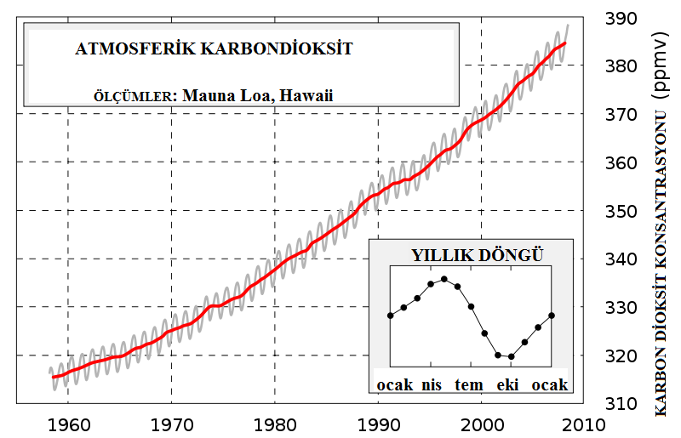

Figure.1.1 Change in carbon dioxide concentration in the atmosphere between 1960 and 2010
(http://en.wikipedia.org/wiki/File:Mauna_Loa_Carbon_Dioxide-en.svg)

2. CLIMATE MODELS

One of the most appropriate methods of understanding climate change is to produce projections for the past and the future with climate models. Climate models are computer programs based on mathematical equations that show the interaction between the atmosphere, oceans, land surfaces and glaciers. In climate models, short-wave rays coming to the Earth and long-wave rays leaving the Earth are shown in balance. The imbalance that may occur in these waves causes differences in determining the average temperature. The structure of the models is relatively simple to complex. When we consider a simple model, there is a radiative heat transfer model that perceives the earth as a single point and averages the energy it gives off. More comprehensive ocean-atmosphere-sea ice climate models can easily solve the mass, energy and radiative exchange equations. In recent years, equations that include greenhouse gas generating factors (more water vapor, clouds, carbon dioxide and methane gas...) have been added to the models to better understand the warming trend.

3. GENERAL CIRCULATION MODELS

Global climate models are computer programs that use complex mathematical equations to simulate how and in what way the atmosphere, ocean, land surfaces, glaciers and energy from the sun affect the earth's climate. Dynamic and thermodynamic equations are parametrized in global climate models with resolutions generally between 150-300 km. These models are used to determine weather patterns, understand climate and predict climate change. General circulation models consist of two main components. The first is the dynamical core, which includes the conservation equations under adiabatic conditions, and the other is the physical methods and parameterization.
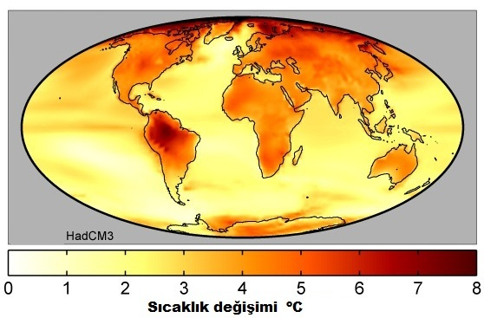

Figure.3.1 Changes in temperature for the years (2071-2100)-(1961-1990) obtained with HadCM3 global climate model
(http://www.whychaos.com).

3.1 Dynamic Core

General circulation models usually make use of the Navier-Stokes equations. These models use imaginary (spectral) semi-Langrangian finite elements to calculate climate parameters (wind, temperature, humidity...).

3.1.1 Horizontal Resolution

For horizontal resolution, grid points in the form of a wire grid dividing the earth's surface into many boxes are used. Different grid structures and different boundary schemes have been designed to reduce errors in horizontal resolution (Messinger, Arakawa, 1976). The smaller the scale of these boxes, the higher the resolution. The model provides more detailed information in the region of decreasing scale, but the larger the number of tiles, i.e. the denser they are, the more equations are computed and the more powerful computers are needed.

Figure.3.2 Arakawa B horizontal resolution grids (http://www.ictp.trieste.it/~pubregcm/RegCM3/workshop.htm).

3.1.2 Vertical Resolution

As with the horizontal, the vertical profile in the atmosphere is also divided into different levels. Models typically use 19 levels in the vertical. Unlike the horizontal, the vertical levels are not evenly distributed. After a certain level, the pressure differences become smaller. For example, the difference between 10000 kilometers and 9000 kilometers is much smaller than the pressure difference between sea level and 1000 meters.
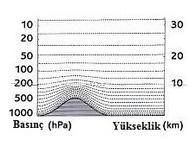
Figure.3.3 Sigma levels (http://climateprediction.net/content/modelling-climate)

3.1.3 Physical Parameterization

Parameterization is used to determine the effects of various processes within the model. There are many parameterization schemes. The most important of these are cumulus convection, large-scale condensation, cloud types, turbulent flux and vertical transport in the planetary boundary layer, cloudiness and vegetation cover. Processes that are not explicitly represented as dynamic or thermodynamic variables in the equations on the model's grids are parametrized and incorporated into the model.

4. REGIONAL CLIMATE MODELS

When examined from a broad perspective, climate change scenarios made with global climate models provide sufficient information to the society and 80-100 year projections for the future can be made with global climate models with a resolution of around 200-300 km, but they cannot provide detailed information in regional terms due to their low resolution. Regional climate models can respond to regional needs by providing more detailed local information in past and future simulations, especially since they can be operated with high resolution (10-50 km). These models, whose resolution is close to numerical weather forecasts, are now widely used in regions of the world with different climatic characteristics (Önol B, 2001).

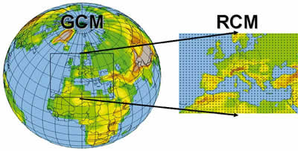

Figure.4.1 Regional climate modeling approach ( http://www.wmo.int/wcc3/bulletin/57_2_en/giorgi_en.html)

4.1 Basic Concepts in Regional Climate Modeling

The general circulation of the atmosphere is shaped by climatic forces such as solar radiation to the Earth, the concentration of greenhouse gases, long-lived stratospheric aerosols, the distribution of oceans and land, large-scale topographic regions (e.g. the Himalayars). Complex topography, coastal patterns, surface vegetation, inland seas and lakes, and short-lived tropospheric aerosols are among the factors affecting regional climate (Giorgi and Mearns 1991). Regional climate models are complementary to global climate models. The general purpose of regional climate modeling is to obtain higher resolution projections by statistical and dynamic downscaling methods using data obtained from global circulation models.
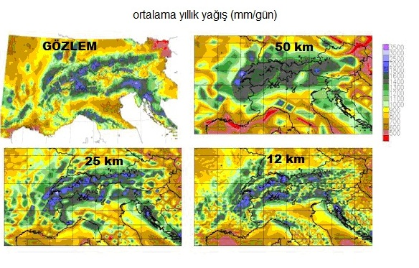
Figure.4.2 Projections at different resolutions derived from observational data and regional climate model (Dequeve et al. 2005)

Regional climate models are based on the concept of downscaling. The aim of downscaling is to obtain regional detail from low-resolution numerical simulations and scattered observations. The principle of downscaling is to make the data thinner, i.e. more detailed, regardless of the resolution of the data used. There are 2 downscaling methods: statistical and dynamic. Statistical downscaling describes the relationship between large-scale atmospheric parameters (e.g. sea level pressure) and station data (temperature, precipitation...). In dynamical downscaling, low-resolution climate parameters obtained from general climate models are made more detailed by means of regional climate models.

The resolution of general circulation models is not sufficient to study regional and local climate parameters. Regional climate models adapted to the GCM (General Circulation Model) increase the model resolution locally. The initial conditions, meteorological boundary conditions (temperature, wind, water vapor, surface pressure) and surface boundary conditions (sea surface temperature, sea ice) required to run the RCM (Regional Climate Model) are obtained from GCMs. This technique is rather unidirectional and there is no feedback from the RCM to the GCM.

The model domain should be chosen to encompass all areas of significant forcing and be large enough to allow the RCM to generate its own internal dynamics. The domain boundaries should not intersect large mountain systems where the topography is complex and high. If they do, the location of the boundary conditions may affect the model accuracy in the internal parameters (Seth and Giorgi 1998).

The use of the same physical schemes in GCM and RCM ensures that the two models are compatible in terms of consistency. Another approach is for each model to use its own physical schematics. Sometimes using the same schematics gives different results at different resolutions (Giorgi and Marinucci 1996)

Quality data and boundary conditions are absolutely necessary for quality RCM simulations. The performance evaluation of regional climate models depends on the perfect fit of the boundary conditions. In these evaluations, boundary conditions are obtained from global meteorological analyses. Especially observation data can limit the model evaluation. These data are obtained from meteorological observation stations, certain regions in the oceans and similar places. However, the fact that the history of meteorological observations is not very old, the oceans are spread over a very large area on the earth's surface, data is obtained from a very small area as a result of the fact that the oceans are spread over a very large area on the earth's surface, and the meteorological observation stations are not evenly distributed in every region are among the biggest reasons limiting the regional model results. In addition, the lack of very high performance computer facilities affects the resolution of regional climate models and the length of simulations.

5. CLIMATE CHANGE PRACTICES WITH REGIONAL CLIMATE MODELS

Over the last 15 years, regional climate models have been used in many studies and RCM performances have improved with the advancement of technology over time. In the early years of regional modeling, climatological deviations, especially in temperature and precipitation, were almost 50%. Today, in state-of-the-art RCMs, these deviations do not exceed 1-2 ºC for temperature and 25% for precipitation (Giorgi and Mearns 1999).

In many studies related to models, the performance of RCMs has been tested with comparative projects. In these studies, comparisons have been made on conditions that affect the performance of the model such as model area and size, different physical schemes, boundary conditions, resolution of data (Giorgi 2006).

Four different scenarios are used in future climate change studies. These scenarios were prepared by the Intergovernmental Panel on Climate Change (IPCC 2000), jointly established by the World Meteorological Organization and the United Nations Environment Program. In these scenarios, greenhouse gas emissions are calculated and labeled A1, A2, B1, B2. Especially according to the most widely used A2 scenario, emissions are calculated and adapted into the model by assuming population growth close to today's world conditions, economic developments, income differences in regions and the assumption that most countries do not take measures against greenhouse gas increases. In A1 and B1, globalization is emphasized in contrast to the regionalism emphasized in A2 and B2.

One of the most focused topics so far in the studies conducted with regional climate models in understanding climate change has been to address the analysis of two specific time periods. In these analyses, the models are first run for the past period (1961-1990) and the future period (2071-2100). In the next stage, the differences of the data obtained from the models for the two different periods are found and predictions are made about the degree of climate change signal in the future in the region under investigation. More recently, future time periods of a century or more are analyzed in continuous periods (Hewitt et al. 2004).

Climate change analyses performed in continuous periods, as opposed to a single period of time, are more useful in terms of understanding the effects of the model on the system gradually. In these applications, the grid range of the model varies between 20-125 kilometers.

Especially compared to the GCM, the topography is better represented in the RCM, which allows us to analyze changes in precipitation more clearly and provides us with more detailed information and predictions in terms of signaling climate change (Giorgi et al. 1994)

When we look at the studies on paleoclimate, we see that they are limited in number. The first study in this field was written by Hostetler et al. (1991,1994) and some studies have been carried out until today, especially in the 2000s. One of the most beautiful studies on paleoclimate was carried out by Sloan (2006).

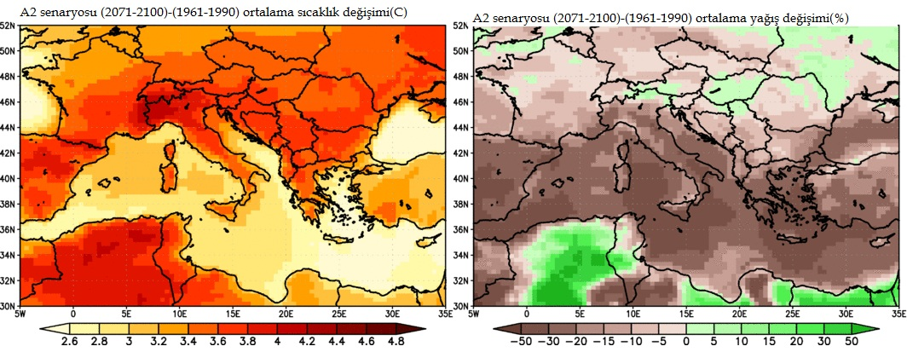

Figure.5.1 Change in temperature and precipitation for the years (2071-2100)-(1961-1990) with (RCM-SEEVCCC) regional climate model A2 scenario
simulations (http://www.seevccc.rs).

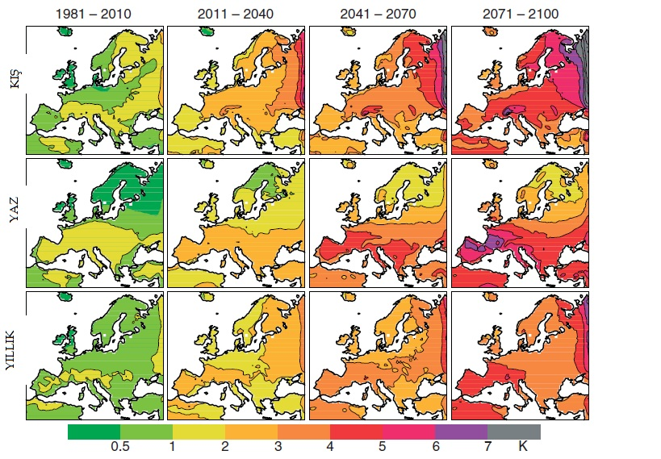

Figure.5.2 Regional analysis of changes in average temperatures in summer, winter, yearly and 30-year continuous periods ( Markku 2010)

5.1 Regional Climate Model Studies in Turkey

Since Turkey is located in the Mediterranean Basin, which is one of the regions that will be most affected by global warming according to the Fourth Assessment Report of the Intergovernmental Panel on Climate Change, predicting the future climate of Turkey is of great importance in terms of preventing or minimizing the effects of climate change (Demir et al. 2008). Although there are many studies on climate change with regional climate models for developed countries in the world, this situation is limited in Turkey

The most important of these projects is the TUBITAK project titled "Climate Change Scenarios for Turkey" jointly conducted by the General Directorate of State Meteorological Affairs and Istanbul Technical University Eurasia Institute of Earth Sciences. Within the scope of this project, the scenario outputs of A2 greenhouse gas emissions obtained from the global climate model were detailed for the time intervals 1961-2000 and 2000-2099 using the downscaling method with 2 different regional climate models. The first results of the project were published in Turkey's First National Communication on Climate Change (First National Communication, 2007). In addition, Önol and Semazzi (2007), Önol et al. (2007), Demir et al. (2007), Demir et al. (2008) have contributed to the issue of climate change in Turkey with regional climate model studies.

6. CONCLUSIONS

Since the resolution of the outputs produced by regional climate models is higher compared to global climate models, they provide much more detailed information on a regional basis. The performance of RCMs depends on the data quality obtained from GCMs and computer technology with high computational power.

For climate simulations, it is necessary to know very well the processes and boundary conditions in the climate system, i.e. solar energy affecting the Earth, the ratio of greenhouse gases in the atmosphere, and the interactions of atmosphere-land-oceans. What people can do, especially for the coming years, is to work by building scenarios on greenhouse gas emissions. This is where the biggest uncertainty comes from, because how the climate will change depends on how much greenhouse gases we will emit into the atmosphere

In recent years, many researchers have turned to studies conducted with regional climate models, which are more useful in understanding the changes that will occur in regional areas, rather than climate change studies that are based on the outputs of global climate models. However, individual studies are insufficient in terms of revealing regional climate changes worldwide as a whole. RCM studies benefit decision makers and society in areas such as agriculture, water resources, energy, glaciers, ecosystems, air pollution, human health and regional economies. With projects to be carried out in coordination with stakeholder dialogues, the usefulness of RCM in research will be increased and at the same time, a worldwide consensus will be achieved on issues related to regional climate change affecting societies.

Global climate models that deal with Turkey spatially in one or a few boxes (grid) are insufficient to reflect the changes in precipitation and temperature caused by topography in detail due to low resolution. Dynamic downscaling techniques act as a bridge between regional climate models and global climate models, helping individuals and institutions to explain more clearly which meteorological process will play a role in which region.

In the Tübitak project "Climate Change Scenarios for Turkey" jointly conducted by the General Directorate of State Meteorological Affairs and Istanbul Technical University Eurasian Institute of Earth Sciences, firstly, the performance of the regional climate model was tested by comparing it with the 1961-1990 observation data obtained from the research units. Then, in order to determine the changes in the 21st century, the range 2011-2100 was analyzed in 30-year periods based on the A2 scenario. According to these results, the temperature increase will remain limited until the 2040s, but after this date, it is predicted that it will increase rapidly and reach up to 6 ^{(o)C} in some regions, although it varies from region to region. When we look at precipitation, especially in winter and spring precipitation, decreases are predicted in the south of the country and increases in the north (Dalfes and Karaca 2008).

It would be erroneous to make definitive judgments about future climate change in Turkey based on the results obtained from a single model and scenario. Obtaining more comprehensive predictions according to the data to be obtained from many regional climate models by many institutions and researchers using different greenhouse gas emission scenarios will be useful for decision makers on major issues such as human health, economic activities, environment, agriculture, water, energy policies, air pollution, regional development in Turkey

7. SOURCES

[1] Dalfes, N and Karaca, M.,. "Climate Change Scenarios for Turkey" TUBITAK KAMAG Project, 2008 105G015
[2] Demir İ., Kılıç G., Coşkun M., PRECIS Regional Climate Model Studies for Turkey and its Region, Proceedings of I. Turkey Climate Change Congress, Istanbul, 2007, p252-261.
[3] Demir, İ., Kılıç, G., Coşkun, M. Climate Predictions for Turkey with PRECIS Regional Climate Model: HadAMP3 SRES A2 Scenario, IV. Atmospheric Sciences Symposium, Proceedings, 365-373. ITU Faculty of Aeronautics and Astronautics, Department of Meteorological Engineering, March 25-28, 2008Istanbul.
[4] Deque, M., R.G. Jones, M. Wild, F. Giorgi, J.H. Christensen, D.C. Hassell, P.L. Vidale, B. Rockel, D. Jacob, E. Kjellstrom, M. de Castro, F. Kucharski and B. van den Hurk: Global high resolution versus limited area model climate change scenarios over Europe: quantifying confidence level from PRUDENCE results. Climate Dyn., 2005, 25, 653-670.
[5] First National Communication of Turkey on Climate Change, 2007.
[6] Giorgi F., Mearns LO., Approaches to the simulation of regional climate change: A review, Rev Geophys., 1991, 29:191-216.
[7] Giorgi F., C. Shields Brodeur, and G.T. Bates, 1994: Regional climate change scenarios over the United States produced with a nested regional climate model, Journal of Climate, 1994, 7, 375-399.
[8] Giorgi F. and M.R. Marinucci, Improvements in the simulation of the surface climatology of the European region with a nested modeling system, Geophysical Research Letters, 1996, 23, 273-276.
[9] Giorgi F. and L. O. Mearns, Introduction to special section: Regional climate modeling revisited, J. Geophys. Res., 1999, 104, 6335-6352.
[10] Giorgi, F., Regional climate modeling: Status and Perspectives. Journal de Physique IV, 2006, 139, 101-118
[11] Hewitt CD., Griggs D., Ensembles-based predictions of climate changes and their impacts, Eos Trans., 2004, 85:566.
[12] Hostetler, S.W., and F. Giorgi, Use of a regional atmospheric model to simulate lake-atmosphere feedbacks associated with Pleistocene Lakes Lahontan and Bonneville, Climate Dynamics, 1991 7, 39-44.
[13] Hostetler, S.W., F. Giorgi, G.T. Bates and P.J. Bartlein, The role of lake-atmosphere feedbacks in sustaining paleolakes Bonneville and Lahontan 18,000 years ago. Science, 1994, 263, 665-668.
[14] Markku Rummukainen, State-of-the-art with regional climate models, Wiley Interdisciplinary Reviews: Climate Change 1:1, 2010, 82-96
[15] Messenger and Arakawa, F. Messenger and A. Arakawa, Numerical methods used in atmospheric models, In: GARP Publication series, No. 17, World Meteorological Organization, Geneva 1976, p. 64
[16] Nakicenovic, N. and R. Swart, Eds. IPCC. 1.5. Why New IPCC Emissions Scenarios? In: Chapter 1: Background and Overview. In: IPCC Special Report on Emissions Scenarios 2000.
[17] NASA, Global Climate Change 2008 http://climate.jpl.nasa.gov/index.cfm
[18] Önol B, Simulation of the Climate of Turkey and Vicinity with a Regional Climate Model: Sensitivity to Surface Conditions Master's Thesis, Istanbul Technical University, Institute of Science and Technology, 2001.
[19] Önol B., Semazzi, F., Unal, Y. S., Dalfes H. N., 2007. "Regional Climatic Impacts of Global Warming over the Eastern Mediterranean", Proceedings of the International Conference on Climate Change and Middle East; Past, Present and Future, 20-23 November 2006, Istanbul.
[20] Önol, B. and Semazzi, F., H., Regionalization of Climate Change Simulations over Eastern Mediterranean, Journal of Climate, 2007.
[21] Seth A. and F. Giorgi, The effect of domain choice on summer precipitation simulation and sensitivity in a regional climate model. Journal of Climate, 11, 1998, 2698-2712.
[22] Sloan L. and Thrasher B., "The Effects of Paleoelevation on the Early Eocene Climate of Western North America," Eos Trans. AGU, 87(52), Fall Meet. Suppl, 2006
[23] http://climateprediction.net/content/modelling-climate
[24] http://en.wikipedia.org/wiki/File:Mauna_Loa_Carbon_Dioxide-en.svg
[25] http://www.ictp.trieste.it/~pubregcm/RegCM3/workshop.htm
[26] http://www.seevccc.rs
[27] http://www.whychaos.com.
[28]

